7COM1079-0901-2025 - Team Research and Development Project

Final report title: ([NeurIPS 2020] Data Science for COVID-19 (DS4C))

Group ID: B127

Dataset number: Ds339

Prepared by: Sara siby anchanattu : 24077789
Rohith Reddy kuchuri : 24078371
Aerolla sathvik rao : 24078391
Junaid afshar Mohammed : 24077302

University of Hertfordshire
Hatfield, 2025

Table of Contents_Toc216106155
1.Introduction 3
1.1 Problem Statement and Research Motivation 3
1.2 The Dataset 3
1.3 Research Question 3
1.4 Null and Alternative Hypothesis 3
2.Background Research 4
2.1 Research Papers Relevant to the Topic 4
2.2 Why This Research Question Is of Interest 4
3. Visualisation 4
3.1 Appropriate Graphs for the RQ 4
3.2 Additional information relating to understanding the data 5
3.3 Useful information for the data understanding 6
4. Analysis 6
4.1 Statistical test used, justification, and output 6
4.2 Interpretation of results and conclusion based on p-value 6
5. Evaluation – Group’s Experience 7
5.1 What went well 7
5.2 Points for improvement 7
5.3 Group’s time management 7
5.4 Project’s overall judgement 8
5.5 Group changes and GitHub ID amendments 8
5.6 Comment on the GitHub log output 8
6. Conclusions 8
6.1 Results Explained 8
6.2 Interpretation of the Results & Effect on Population / Context 8
6.3 Future Work, Limitations, Implications 9
7.References 9
Appendices 10
Appendix A: R code 10
Appendix B 11

1.Introduction

1.1 Problem Statement and Research Motivation
The COVID-19 pandemic has brought unprecedented challenges for public health, infection clusters being among the greatest threats for rapid spread. Outbreaks of clusters, e.g. at social events, workplaces, or religious ceremonies, have proven to spread faster than sporadics, potentially overwhelming health care systems. Determining if cluster infections tend to be associated with a larger number of confirmed cases is also valuable for formulating targeted containment measures and effectively distributing resources among affected areas. Prior studies have shown that cluster events contribute to the majority of COVID-19 transmission when compared to sporadic cases in the community (Kim et al., 2020).

1.2 The Dataset
This is information about confirmed cases of COVID-19 in South Korea that has been collected through reports, containing the information of the date when confirmed, geographic information, type of infection, number of cases related to the instance of infection. Variables are province, city, cluster, lat, lon, total confirmed counts. It can differentiate between cluster and non-cluster cases, which may be helpful for statistical analysis for patterns of infection. The data lend themselves to a difference-in-means analysis because the case counts are continuous and there are two well-defined groups.

1.3 Research Question
Infection from a cluster event, where a large group of people get infected at once, is suspected to cause more cases than individual event infections, which do not have a cluster effect.
Objectives: To evaluate whether differences could be detected in outcomes between cluster cases and non cluster cases, to contribute to knowledge of transmission severity.

1.4 Null and Alternative Hypothesis
Null hypothesis (H₀) : There is no difference in the number of confirmed cases between cluster and non-cluster COVID-19 infections. This means that magnitude and severity of the reported cases do not depend on whether the infection was acquired from a cluster event.
Alternative hypothesis (H₁): The confirmed cases in cluster infections and in non-cluster infections are significantly different; suggesting that the cases with cluster origins may lead to a larger number of confirmed infections. We will use statistics to gage whether the differences we observe are meaningful, or attributable to random variation.

2.Background Research

2.1 Research Papers Relevant to the Topic
Cluster-based transmission has been extensively studied during the COVID-19 pandemic, and clusters have been reported as a major cause of rapid viral spread in numerous reports. Kim et al. (2020) reported that cluster events led to exponential growth in confirmed cases in South Korea based on the analyses of major outbreaks, especially in religious and workplace clusters. In a similar way, Lemieux et al. (2021) illustrated how a single cluster event in Boston was the source of broad secondary transmission using genomic tracing analysis, demonstrating that cluster infections may lead to an outsized share of total cases. This was substantiated by the findings of a case study of 20 clusters by Adam et al. (2020), which revealed that the majority of infections (80%) were derived from a minority of clusters (<20%), emphasizing the highly skewed transmission nature of COVID-19. Collectively, these findings highlight the need to determine whether cases that are cluster-associated tend to result in greater confirmed case numbers. Albeit already well researched are the questions of where clusters are formed and how far they spread, there are relatively few studies that quantitatively compare cluster and non-cluster outcomes based on open source public health data. Thus, it provides us a chance to investigate if there are significant statistical differences and if so, to offer insight into resource allocation and preventive measures.

2.2 Why This Research Question Is of Interest
Although prior studies indicate that cluster events accelerate COVID-19 spread, up to now there is still a lack of statistical comparison on the number of confirmed cases between cluster infections and non-cluster infections based on publicly available data. This is a relevant question in terms of risk perception, because knowing if clusters always or on average yield higher case counts than non-cluster infections might support focused intervention strategies (e.g. enhanced testing or restrictions on high-risk environments). ‘What to look for Whats New in the Future The identification of differences also helps to inform future management of the pandemic and preparedness planning. The results of this study could warrant additional research investigating cluster characteristics such as size, region and demographics to foresee and avert large scale outbreaks.

3. Visualisation

3.1 Appropriate Graphs for the RQ

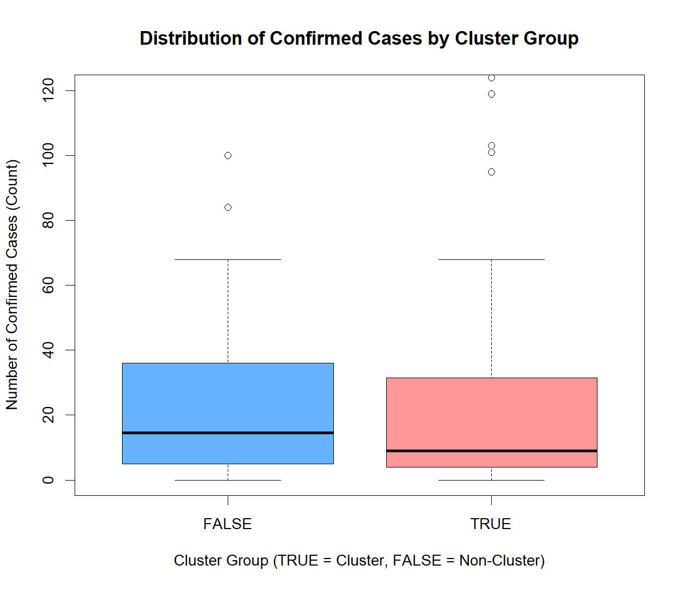
Figure 1: Boxplot – Confirmed Cases by Cluster Group

A boxplot was chosen as the primary visualization as it allows clear comparison of the distribution and central tendency of confirmed cases between cluster and non-cluster individuals. A histogram of confirmed cases is displayed to check for normality and to justify the employed statistical test. A summary table adds clarity by showing the mean and median of the two groups.

3.2 Additional information relating to understanding the data

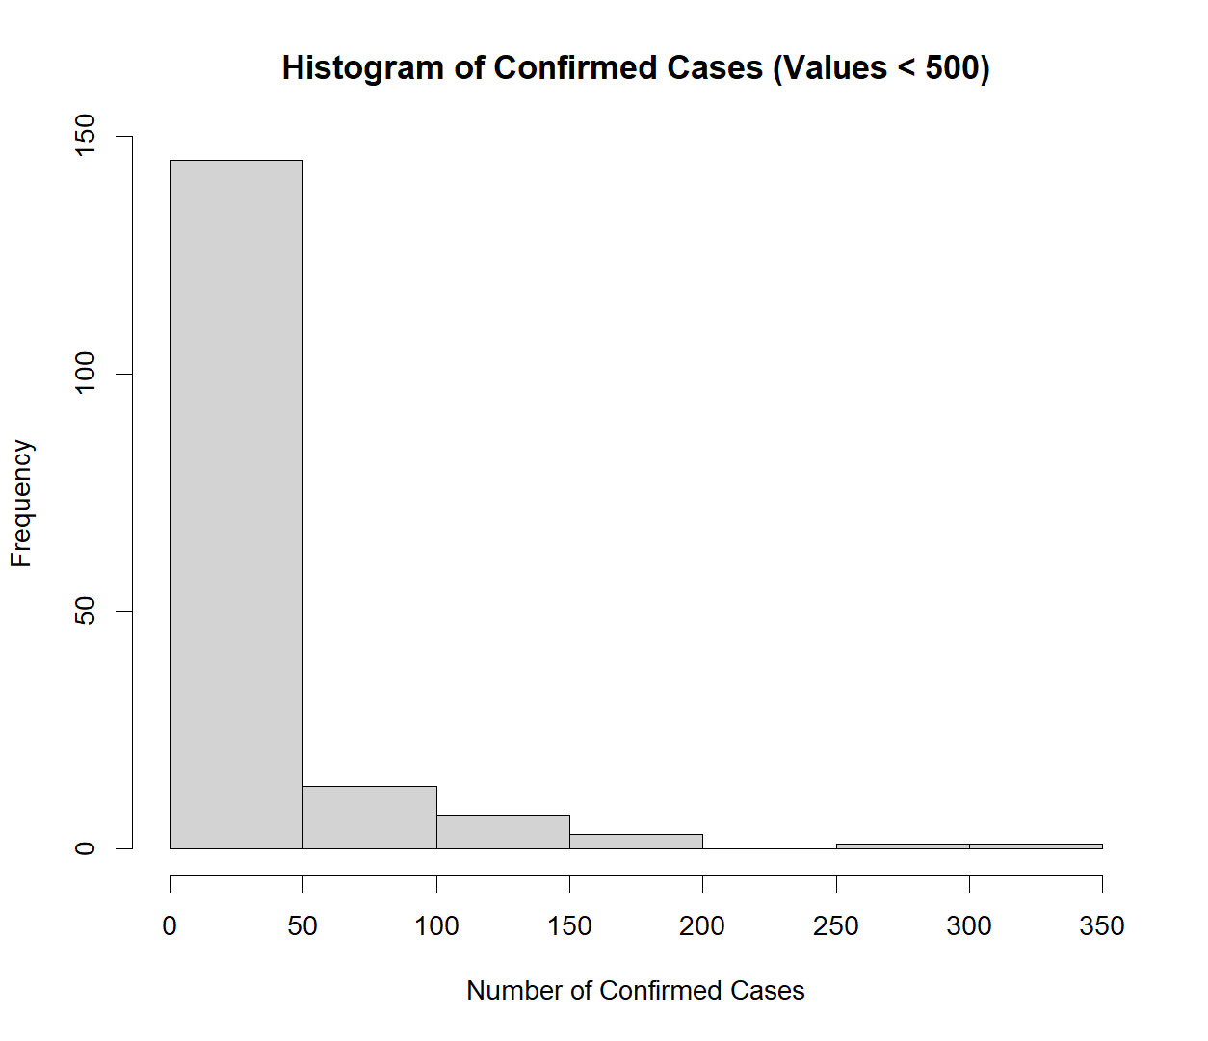
Figure 2: Histogram of Confirmed Cases

The range, median and several outliers can be clearly seen for two groups in the boxplot, suggesting a spread out distribution for confirmed cases of the disease. The histogram shows a large number of small case counts and a long right tail, suggesting that the data is strongly right skewed. This skew decides which statistical test needs to be used.

3.3 Useful information for the data understanding
The visualisations show that most confirmed cases are under 50, but a few outliers stretch the upper range considerably. The two groups have similar dispersion and they overlap so there is no gross visually apparent difference. The skewed distribution together with the outliers indicate that a non-parametric test should be used to compare the two groups.

4. Analysis

4.1 Statistical test used, justification, and output
The Wilcoxon rank-sum test was used to compare the numbers of confirmed COVID-19 cases in cluster and non-cluster groups. This test is suitable because the research question considers a difference between two independent groups and by inspection of the histogram and based on the Shapiro–Wilk test (p < 0.001) the data is not normally distributed with obvious right-skew and several outliers. So a non parametric version was needed. As a non-parametric measure of central tendency, the Wilcoxon allows a robust comparison of median case counts without normality assumptions.

4.2 Interpretation of results and conclusion based on p-value
Wilcoxon rank-sum test p-value=0.1068>0.05 level, the null hypothesis cannot be rejected. Therefore, the null hypothesis cannot be rejected. This means that there is no evidence to suggest that the number of confirmed cases per day is distributed differently across cluster and non-cluster groups in this sample. While there does appear to be some slight variation in median values (based on descriptive statistics), these differences are not strong enough to provide statistical evidence for a meaningful effect. Consequently, these results imply that cluster-associated cases did not exhibit significantly higher confirmed case counts compared to non-cluster cases during the period covered by this dataset.

5. Evaluation – Group’s Experience

5.1 What went well
Our team worked well together, we communicated regularly through online meetings and shared documents to have clearly defined tasks and good workflow. The initial planning phase clarified expectations and save us from duplicating efforts. GitHub allowed us to be transparent with version control and serve as a dependable backup for our files. Everyone had meaningful input in discussions, and it was during our collective struggle to solve statistical analysis that understanding truly dawned and the quality of our report solidified.

5.2 Points for improvement
One focus for improvement could be earlier involvement in data cleaning and preparation, since bottlenecks at this stage led to time pressure as the deadline approached. Also, firmer scheduling and more definite interim deadlines would have prevented work at the last moment. Better documentation of decisions would also help in future projects, particularly when multiple versions of files were worked on. I think finally, perhaps more active recruitment of the more reticent members to speak up (if that’s possible) could ensure a better balance and perhaps a more even sharing of duties.”

5.3 Group’s time management
Time management got better as the project went on but was erratic at first. Progress became more regular and quantifiable when the weekly milestones were established. The last phase took more concentrated work than expected, suggesting that earlier finishing of groundwork and more detailed thinking ahead are needed for cooperative task.
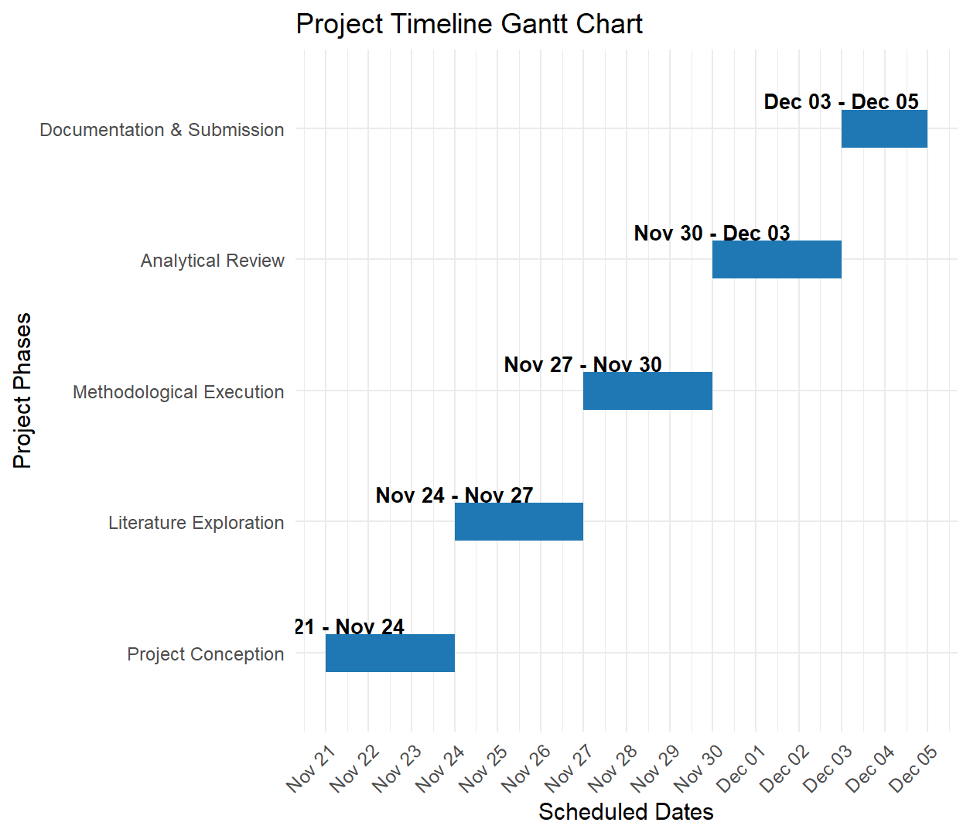

5.4 Project’s overall judgement
The analysis was solid and well-based on sound statistical methods with good visualisations. The partnership fostered mutual learning and collaborative problem solving. Although the process could have been strengthened through better planning, the end result is one of effective team work and demonstrates a high degree of enthusiasm for the research question and dataset.

5.5 Group changes and GitHub ID amendments
No changes were made to the group following the initial allocation, and therefore no new GitHub IDs were added or amended for this project. All members retained their originally assigned roles and contributed as planned throughout the duration of the assignment.

5.6 Comment on the GitHub log output
The GitHub log were indicative of version control with information about when updates were made and which parts were updated. It was useful for monitoring progress, and it allowed access to the earlier versions if the need arose. The output of the GitHub log is put in Appendix B and referred to in the appropriate place in the report.

6. Conclusions

6.1 Results Explained
We compared the distributions of reported number of confirmed COVID-19 cases between cluster and non-cluster groups using the Wilcoxon rank-sum test. The results showed that there was no statistically significant difference between the two groups (p = 0.1068) and that the difference may have been by chance could rather than the effect of clustering. The descriptive statistics showed slight differences in mean and median but this difference was not enough to reject the null hypothesis. Thus, clustering did not have a definitive effect on cases.

6.2 Interpretation of the Results & Effect on Population / Context
These results indicate that spread of infection in the dataset was not heavily reliant on cluster transmission, and that single-host transmission and/or sporadic community spread may have played similar roles. This outcome has significance for public health decision makers, since focusing solely on cluster areas to contain transmission may not be adequate unless supported with generalized intervention. Further, this illustrates how complex Covid-19 dynamics are so that non-cluster cases could still be a significant risk and should be continuously monitored and resourced with communication efforts.

6.3 Future Work, Limitations, Implications
Future research should consider larger samples, further variables such as mobility and vaccination rates, and longitudinal timelines to enhance the explanation on trends. Generalisation is limited by the small geographic area and lack of contextual factors. However, these findings could inform more comprehensive intervention development, with a focus on both cluster surveillance and general community-level prevention efforts.

7.References

- Kim, S., Seo, Y.B. & Jung, J., 2020. The impact of cluster infections on the transmission dynamics of COVID-19 in South Korea. Journal of Korean Medical Science, 35(36), pp.1–10.
- Lemieux, J.E., Li, J.Z., Beroukhim, R. et al., 2021. Phylogenetic analysis of SARS-CoV-2 in Boston highlights the role of conference-associated superspreading events. Science, 371(6529), pp.1–9.
- Adam, D.C., Wu, P., Wong, J.Y. et al., 2020. Clustering and superspreading potential of SARS-CoV-2 infections in Hong Kong. Nature Medicine, 26(11), pp.1714–1719.

Appendices

Appendix A: R code

# Load the dataset
df <- read.csv("Case.csv", stringsAsFactors = FALSE)

# Keep only confirmed and group
df_mean <- df[, c("confirmed", "group")]

# Convert confirmed to numeric and remove missing
df_mean$confirmed <- as.numeric(df_mean$confirmed)
df_mean <- na.omit(df_mean)

# Convert group into factor
df_mean$group <- factor(df_mean$group)
# Histogram of confirmed cases
hist(df_mean$confirmed[df_mean$confirmed < 500],
main = "Histogram of Confirmed Cases (Values < 500)",
xlab = "Number of Confirmed Cases",
ylab = "Frequency",
col = "lightgray",
border = "black")

# Shapiro test
shapiro.test(df_mean$confirmed)
boxplot(confirmed ~ group, data = df_mean,
main = "Distribution of Confirmed Cases by Cluster Group",
xlab = "Cluster Group (TRUE = Cluster, FALSE = Non-Cluster)",
ylab = "Number of Confirmed Cases (Count)",
ylim = c(0, 120),
col = c("#66b2ff", "#ff9999"), # blue and soft red
border = "black")

#Wilcox Test
wilcox.test(confirmed ~ group, data = df_mean)
summary_table <- aggregate(confirmed ~ group, data = df_mean,
FUN = function(x) c(mean = mean(x), median = median(x)))

summary_table

Appendix B

